**Assignment 1**

1. Get installed docker version:

Command: docker -v



1. Get a list of images:

Command: docker images

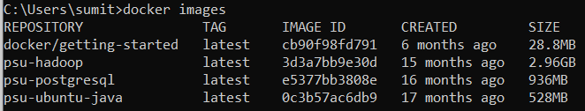

1. Get a list of all running containers:

Command: docker ps



1. Get a list of containers, including the ones that are **not** currently running:

Command: docker ps -a

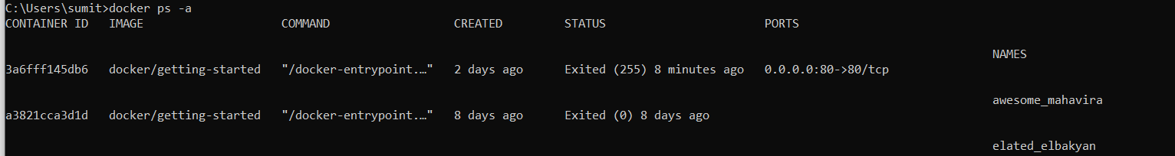

1. Start Docker container:

Command: docker start <container id>



1. Gracefully stop Docker container:

Command: docker stop <container id>



1. Remove a container from this machine:

Command: docker rm <container id>



1. Remove an image from this machine:

Command: docker rmi <image name>

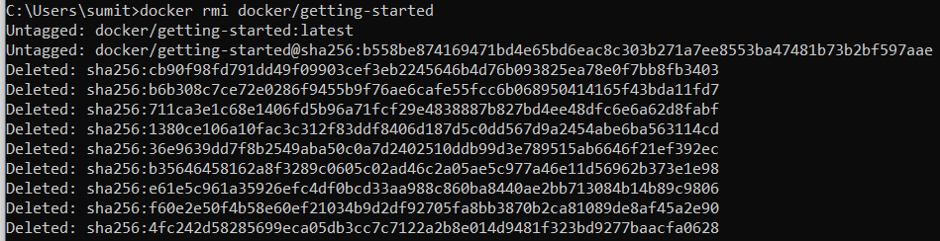

1. Forcefully remove an image from this machine:

Command: docker rmi -f <image name>



1. Pull an image to this machine:

Command: docker pull <image name>

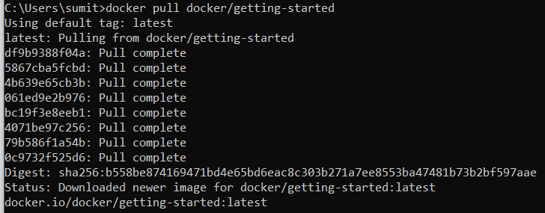

1. Create a container from the pulled image:

Command: docker run -p <host port>:<container port> <image name>

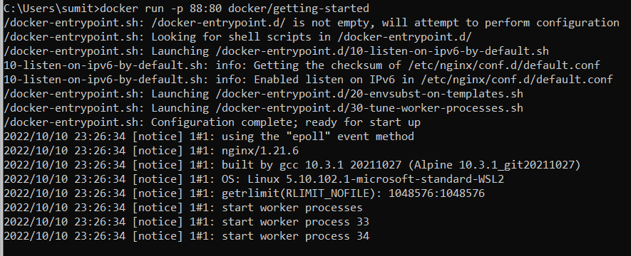

1. Create a container **in detached mode** from the pulled image:

Command: docker run -d -p <host port>:<container port> <image name>



1. Forcefully stop a container:

Command: docker kill <container id>



1. Build a docker image:

Command: docker build -t <image name> .

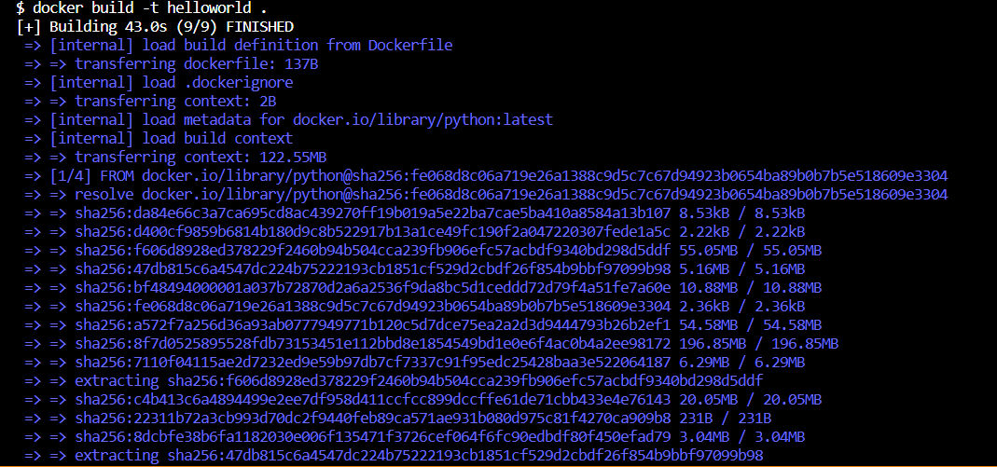

1. Login to Docker Hub:

Command: docker login

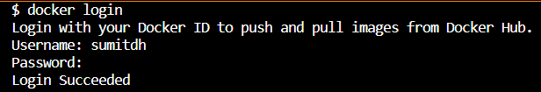

1. Push an image into Docker Hub:

Command: docker push <image name:tag name>

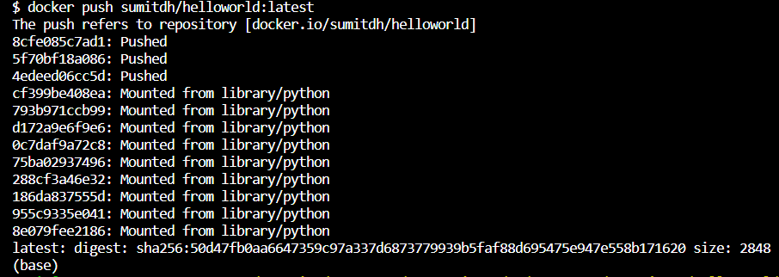

**Assignment 2**

1. Pull the docker image from Docker Hub:

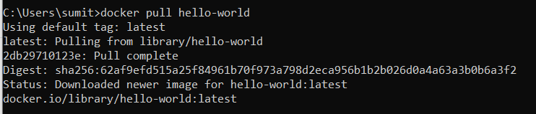

1. Run the image as a container:



1. Check the containers on this machine:



**Assignment 3**

Code in Github:

<https://github.com/sumitdig/Hello-World>

Building Docker image:

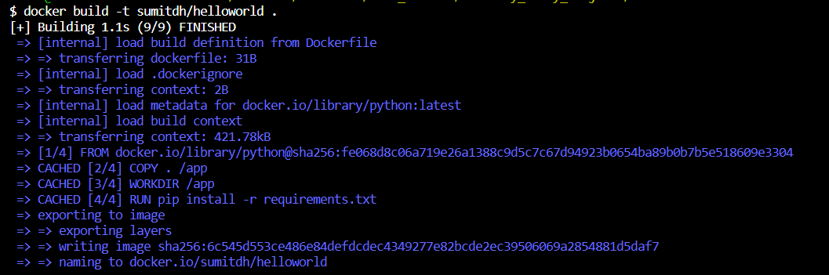

Pushing Docker image to Docker Hub:

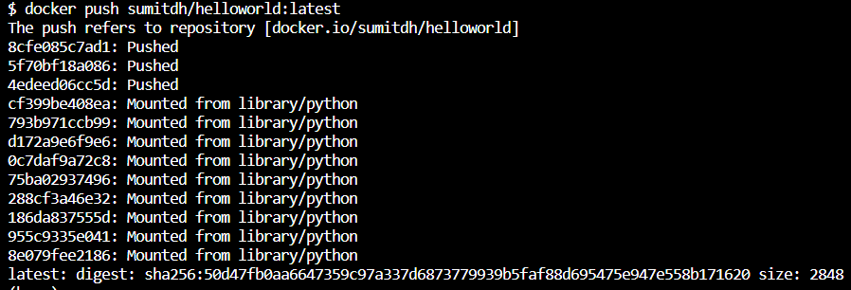

**Assignment 4**